- Prompts for queries
  - Prompt:
    - Please give me a list of 100 queries that are representative of what local landscapers, community leaders, residents of the Indo-Gangetic Plains, or people who work there in the Embassy, etc. would ask our model to give them info on plants that're good for their area or maybe they're curious about finding the right plant for a specific use, etc
  - Response:
Here is the complete list of 100 realistic, region-grounded queries that local landscapers, community leaders, residents, indigenous groups, farmers, school administrators, municipal workers, and embassy staff in the Indo-Gangetic Plains would ask your model.

✅ 100 Representative Queries for the Indo-Gangetic Plains Plant-Recommendation Model

A. General Residents — Everyday Landscaping Needs (1–15)
- “My courtyard only gets morning sunlight. Which flowering plants will still bloom well here?”
- “Which native shrubs won’t attract snakes or rodents near my home?”
- “What plants can I grow on my rooftop that can handle extreme summer heat?”
- “My house is near a dusty road — what plants can help reduce dust entering our home?”
- “Our backyard soil is very hard and cracked. What plants can grow in such soil?”
- “Which plants give good fragrance in the evening for a small home garden?”
- “What plants can I safely grow around my water tank without damaging the structure?”
- “We want a small kitchen herb garden — which medicinal plants are fast-growing and low maintenance?”
- “My lane has almost no shade. Which small trees grow fast and don’t need much watering?”
- “What plants can be planted around the hand pump to reduce slipperiness in monsoon?”
- “Our space is tiny. What potted native plants survive heat waves and look beautiful?”
- “Which plants can help reduce air pollution from nearby traffic?”
- “What native insect-repellent plants are safe for homes with children?”
- “We want plants that keep mosquitoes away — what grows well in this climate?”
- “Our well water is slightly salty. Which plants can tolerate that irrigation water?”

B. Farmers, Agroforestry Workers & Indigenous Communities (16–30)
- “Which plants help restore nitrogen in the soil after paddy cultivation?”
- “What native species can grow on field bunds without disturbing crops?”
- “Which plants help reduce soil erosion on irrigation canal edges?”
- “We need shade trees that won’t harm nearby crops — what should we plant?”
- “Which shrubs attract pollinators to increase yields in nearby farms?”
- “What plants survive best in fields that flood every monsoon?”
- “Which native plants are good fodder for cattle?”
- “Are there native plants that naturally control pests in rice fields?”
- “Which species grow well on sandy riverbank soil and help stabilize it?”
- “Our fields are becoming saline from over-irrigation — what plants can survive this?”
- “Which plants used traditionally by Tharu communities can we grow here?”
- “What medicinal plants used by Santhal healers can be cultivated locally?”
- “Are there plants that work well in rice-fish integrated farming systems?”
- “Which native species can regenerate degraded grazing lands?”
- “What plants improve soil structure through deep or fibrous roots?”

C. Local Landscapers & Garden Contractors (31–45)
- “Which native plants can replace expensive exotic hedge species?”
- “What fast-growing species are best for creating privacy screens?”
- “Which local plants become invasive and should be avoided in landscaping?”
- “For a government office, what native plants look formal and require little maintenance?”
- “Which plants tolerate reflected heat from concrete walls and pavements?”
- “What species can be planted near septic tanks without damaging pipes?”
- “Which shrubs flower through most of the year in this climate?”
- “Which plants can handle both winter fog and harsh summer heat?”
- “We need plants that stay green during water shortages — what native options exist?”
- “Which groundcovers suppress weeds without becoming invasive?”
- “What native plants can be used instead of lawn grass for a low-water landscape?”
- “Which species are safe to plant under overhead power lines?”
- “Which plants tolerate poor, rocky roadside soil?”
- “What native ornamental species are commonly used in public parks?”
- “Which plants soften building edges and give a welcoming appearance without heavy watering?”

D. Community Leaders, Schools, Temples & Public Spaces (46–60)
- “We want culturally significant plants around our temple entrance — what should we choose?”
- “For school gardens, which native plants are safe for children to interact with?”
- “Which plants flower during major festivals like Holi, Diwali, or Eid?”
- “Our community hall needs shade trees — which ones don’t drop large branches?”
- “Which plants support local bird species for educational projects?”
- “What species can create a butterfly garden in the village?”
- “We want native plants for a biodiversity corner — what should we include?”
- “Which flowering plants bloom in winter to brighten public spaces?”
- “Our playground is very dusty — what plants can help hold the soil?”
- “Which plants have interesting folk stories we can highlight on educational signage?”
- “What trees are traditionally planted along village roadsides for shade?”
- “Our Panchayat wants a medicinal plant garden — which native species should we feature?”
- “What plants are sacred to both Hindus and Buddhists and grow easily?”
- “What plants improve drainage and reduce mud near community water taps?”
- “Which species are good for marking boundaries without creating safety hazards?”

E. Embassy Staff & Embassy Operations (61–75)
- “Which native plants best represent northern India’s ecological heritage for diplomatic events?”
- “What low-maintenance species are ideal due to limited gardening staff?”
- “We need plants that look presentable year-round for official photo backdrops.”
- “Which native aquatic plants are safe and aesthetic for embassy water features?”
- “Which culturally neutral plants can be used near quiet reflection or prayer areas?”
- “Which native plants are viewed positively across Hindu, Muslim, Sikh, and Buddhist communities?”
- “Which species can create shaded walkways for staff during hot seasons?”
- “Which plants minimize allergies for embassy staff?”
- “What plants help deter insects around outdoor meeting spaces?”
- “Which native shrubs and trees can help reduce noise along the embassy perimeter?”
- “Are there plants we should avoid due to cultural sensitivities?”
- “Which species help reduce overall water consumption in embassy landscaping?”
- “What plants thrive near constant security lighting during the night?”
- “Which species survive both monsoon flooding and severe summer drought inside the compound?”
- “What plants are ideal for educational signage about ecological or cultural significance?”

F. Climate-Specific Problems (Flooding, Salinity, Heat, Soil Issues) (76–90)
- “Our land floods knee-deep every monsoon — what long-term plants can survive this?”
- “Which plants recover quickly after prolonged waterlogging?”
- “Our soil has become alkaline — what native plants tolerate alkaline conditions?”
- “Summers are getting hotter — which drought-tolerant trees thrive here?”
- “Which plants handle cycles of wet monsoon and dry winter well?”
- “Which salt-tolerant plants can grow in full sun?”
- “Our village well rarely fills now — what ultra-low-water plants are suitable?”
- “Which species tolerate foggy winters near the Himalayan foothills?”
- “What plants grow well in gravelly riverbank soil?”
- “Which shrubs can withstand strong winds during pre-monsoon storms?”
- “What species adapt best to sandy, unstable soils in floodplain areas?”
- “Which plants can survive occasional frost in the upper plains?”
- “What perennial flowering plants last longest in drought conditions?”
- “Which local species have deep roots that access groundwater in dry months?”
- “What native plants best serve as windbreaks for agricultural land?”

G. Cultural, Historical & Traditional Knowledge Queries (91–100)
- “Which plants are used in Mithila art and can be grown in home gardens?”
- “What plants have significance in Bhojpuri festival traditions?”
- “Which native species are central to Tharu cultural ceremonies?”
- “Which local medicinal plants help with digestion or fever and are easy to grow?”
- “What plants mentioned in the Ramayana or Mahabharata grow well in this region?”
- “Which plants symbolize prosperity or protection in local customs?”
- “We want a garden showcasing Indo-Gangetic identity — which iconic species should we plant?”
- “What native plants are used for natural dyes in traditional crafts?”
- “Which plants are used in traditional livestock medicines in rural communities?”
- “What native flowers are commonly offered in Hindu temples?”

- Prompts for coding help
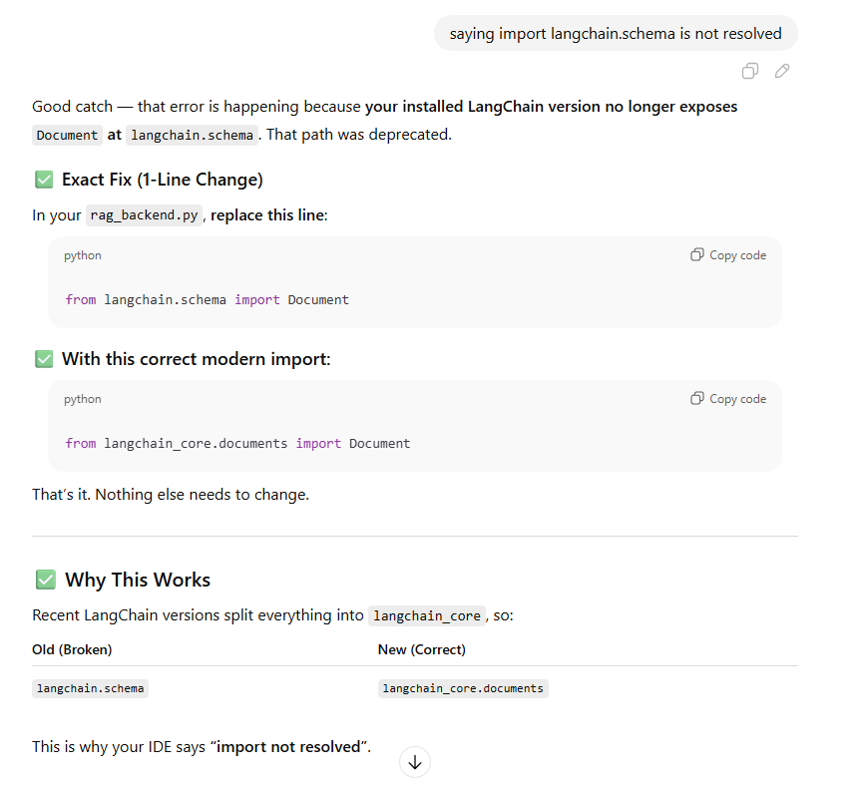
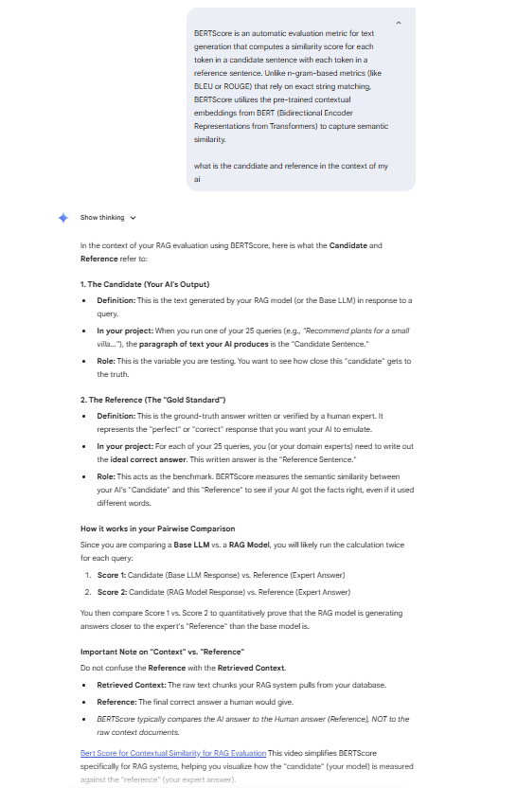
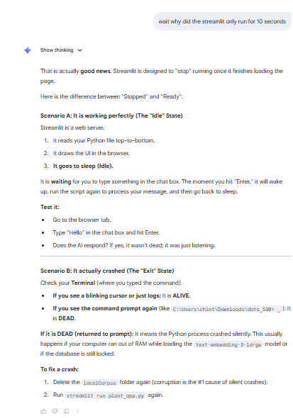

- Prompt: I am getting a ValueError when trying to ingest data into ChromaDB. It says expected embeddings to be a list of floats but got an array. How do I fix this type mismatch? AI Response: Identified the conflict between the native ChromaDB client and LangChain's wrapper. Provided Python script to re-ingest the 'CleanCorpus.csv' using 'CSVLoader' and 'OpenAIEmbeddings' to ensure correct data types.
- Category: Debugging Prompt: My Python script is throwing a ModuleNotFoundError: No module named 'langchain_core.memory'. What causes this version conflict? AI Response: Explained that the error stems from legacy 'langchain.agents' dependencies clashing with newer 'langchain-core' versions. Provided a refactored 'rag_backend.py' using stable LangChain Expression Language (LCEL) syntax to resolve the crash.
- Category: UI Refinement Prompt: The text in my Streamlit app is invisible because it is white on a white background. How can I write CSS to force the text color to black? AI Response: Diagnosed a 'Dark Mode' theme conflict. Provided updated CSS for 'app.py' adding 'color: #1E1E1E !important' to the global body style to ensure text visibility regardless of system theme settings.
- Category: Debugging Prompt: I am getting a NameError for 'HumanMessage' in my batch processing loop. Which library do I need to import? AI Response: Identified the missing import statement. Provided the corrected code block adding 'from langchain_core.messages import HumanMessage' to the batch processing script.
- Category: Concept Clarification Prompt: What is the best way to structure a Streamlit app so the database doesn't reload every time a user clicks a button? AI Response: Explained the Streamlit execution model and recommended the '@st.cache_resource' decorator. Provided a 'Two-File Architecture' (app.py and rag_backend.py) to separate the interface from the heavy database initialization logic.
- Category: Visualization Prompt: What is the standard syntax for melting a pandas DataFrame so it can be used in a Seaborn bar chart? AI Response: Provided the 'pd.melt()' syntax to convert the wide-format evaluation results into a long-format DataFrame suitable for Seaborn's 'sns.barplot' function.
- Category: Conceptual UnderstandingPrompt: Can you explain conceptually how the 'text-embedding-3-small' model converts my plant descriptions into numbers? I want to understand how the system matches "hair health" to "soap pod" if the words aren't exactly the same.AI Response: Explained the concept of high-dimensional vector space where semantically similar concepts (like "hair health" and "medicinal shampoo") are mapped closer together, allowing the cosine similarity search to find relevant matches even without exact keyword overlap.
- Category: Parameter TuningPrompt: In the ChatOpenAI initialization, I set temperature=0. What is the technical implication of this setting for a scientific task?AI Response: Explained that temperature=0 forces the model to be deterministic, always choosing the most probable next token. This is crucial for scientific RAG tasks to minimize creativity/hallucination and ensure the output strictly adheres to the retrieved context.
- Category: Data StructurePrompt: What does the CSVLoader actually do with the rows? Does it treat each row as a separate document or chunk the whole file?AI Response: Confirmed that CSVLoader treats each row as a distinct "Document" object with page_content containing the cell values and metadata containing the row number/source. This granularity allows the retriever to pull specific plant entries rather than the entire dataset.
- Category: Prompt EngineeringPrompt: I am trying to explain the 'Role and Goal' section of my system prompt to a non-technical audience. How does defining a 'Persona' technically influence the LLM's output?AI Response: Explained that the System Message sets the initial context window or "state" of the model, effectively priming the probability distribution of generated words to align with the specific vocabulary and tone of the defined expert persona (e.g., a Botanist).
https://github.com/VihanP29/indo-gangetic-RAG-framework

